

|  |
| --- |
| **Companies Planning** |
|  |
| *Smart Vision (SVG) Phase 2* |

Email Handling Optimization for ERPNext

# Introduction

We currently have direct email integrations configured with our domains, and the basic sending/receiving functionalities are working as expected. However, we are facing issues in handling CC/BCC and emails sent to multiple recipients. ERPNext only saves a single copy of such emails due to how it handles the Message-ID, which causes problems with visibility and tracking across different recipients.

# Proposed Technical Solution:

1. **Unique Message Identifier:**
   * Modify the message ID logic by appending the recipient’s email address.

**Format:** message-id + recipient-email

* + This ensures ERPNext treats the same email as a unique message per recipient.

# Support for CC/BCC:

* + Apply the same logic for CC and BCC recipients.

**Format Example:** message-id + cc-email, message-id + bcc-email

# Direct ERP Back-End Modification:

* + Avoid using external APIs.
  + Modify ERPNext's core or custom email handling files directly for processing and storing these enhanced message IDs.

# Preserve Email Content:

* + Ensure **incoming and outgoing** emails retain:
    - Embedded **images**
    - **Signatures**
    - **Attachments**

1. **Handle Subject Duplication:**
   * Append the current **date and time** to email subjects to avoid duplication.

**Example:** Original Subject + [YYYY-MM-DD HH:MM:SS]

# Forward Email Control Mechanism:

* + Create a custom Doctype: **Forward Emails Control**
    - Fields:

# Target Role

* + - * **Target Email Account**
    - Purpose:
      * Define which emails should be auto-forwarded by role.
      * Group incoming/outgoing emails per role for centralized monitoring.

# Email Processing Logic:

* + Backend script must:
    - **Check if email has already been processed** (by searching in To, CC, or BCC using the enhanced message ID).
    - If not found:
    - Create a new message ID: message-id + date + time
    - Process send/receive and store accordingly.

# Email Provider Compatibility:

* + Design the logic to work with **any email provider** (Gmail, Hotmail, Yahoo, etc.).
  + Avoid provider-specific assumptions.

# Email Processing Flowchart:

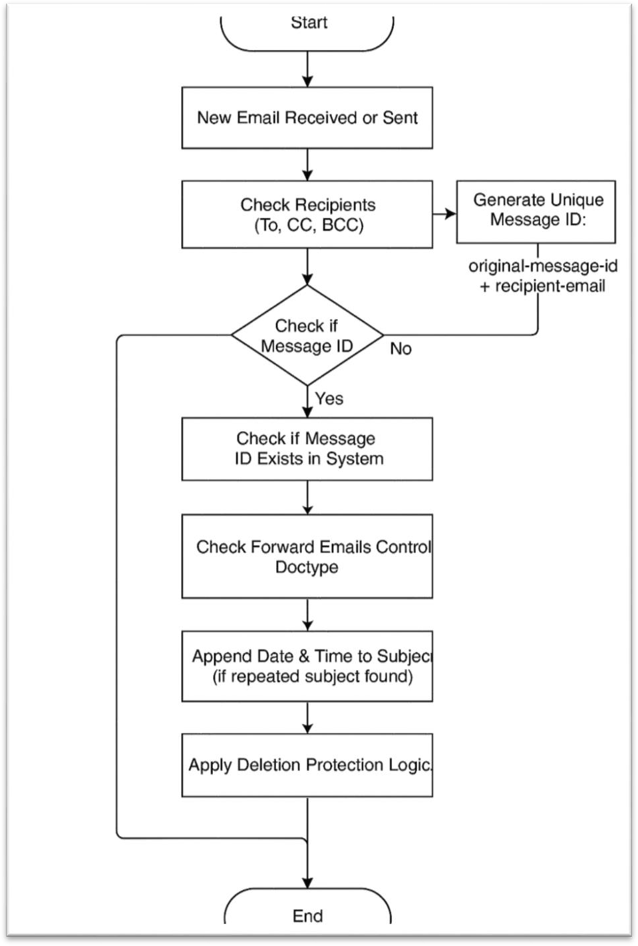

**Tendering & Supervision Solution (Sending & Receiving System)**

# Introduction

The Email Tendering & Supervision Solution is designed to transform incoming and outgoing emails into trackable tasks and projects with automated workflow management. This system bridges external communications with internal process management, ensuring no email goes untracked and all communications follow proper supervision protocols.

# Proposed Technical Solution:

**Purpose**

Convert email communications into structured, trackable business processes with automated assignment, monitoring, and reporting capabilities.

# Key Benefits

* **Process Automation**: Automatic task creation from emails
* **Centralized Monitoring**: Single dashboard for all email-based tasks
* **Accountability**: Clear assignment and tracking of responsibilities
* **Audit Trail**: Complete history of all communications and actions
* **Integration**: Seamless connection between email systems and internal workflows

# Core System Components

1. Email Processing Engine

# Functionality:

* + Automatically captures incoming and outgoing emails
  + Creates corresponding records in the Email Monitoring system
  + Maintains bidirectional link between emails and system records
  + Supports multiple email accounts and business domains

# Technical Requirements:

* + Real-time email synchronization
  + Duplicate detection and prevention
  + Email parsing and metadata extraction
  + Secure email content storage

1. Task Management Framework

# Core Doctypes & Data Structure:

1. **Email Monitoring (Primary Doctype)**
   * **Email Reference**: Direct link to original email with full functionality
   * **Email Type**: Issued (Outgoing) / Incoming
   * **Priority Level**: High / Medium / Low
   * **Current Status**: (See status workflow below)
   * **Assignment Details**: User, department, and role-based assignments
   * **Email Account**: Associated business or engineering account
   * **Tags**: Flexible categorization system (configurable doctype)
   * **Notes**: Assignment notes and instructions

# Email Tags (Configurable Doctype)

* + **Tag Name**: Customizable categories
  + **Tag Description**: Detailed tag information
  + **Department Association**: Link tags to specific departments
  + **Color Coding**: Visual identification system

# Email Status Workflow

1. **Open**: Initial status for new emails
2. **Need Reply**: Requires response from assigned user
3. **Replied**: Response has been sent
4. **Follow Up**: Requires additional action or monitoring
5. **Follow Up Review**: Pending supervisor review
6. **Closed**: Task completed and archived

# Detailed System Workflows

1. Email Intake Process

# Automatic Email Processing:

* 1. System detects new incoming/outgoing email
  2. Creates new Email Monitoring record
  3. Extracts relevant metadata (sender, subject, priority indicators)
  4. Sets initial status to "Open"
  5. Triggers notification to monitoring team

# Email Linking System:

* + - Popup prompt asks users to link related emails
    - Creates relationship chains between connected communications
    - Maintains conversation history and context
    - Enables comprehensive case tracking

1. Assignment & Monitoring Workflow

# Task Assignment Process:

* 1. Monitoring team reviews new Email Monitoring records
  2. Assigns tasks based on content, department, and expertise
  3. Sets priority level and expected response timeframe
  4. System sends notification to assigned user
  5. Task appears in assignee's dashboard with priority ordering

# Response Management:

1. Assigned user receives email task notification
2. User accesses original email with full reply/forward capabilities
3. Upon sending reply, status automatically updates to "Replied"
4. Monitoring team receives completion notification
5. Supervisor reviews and determines next action (follow-up or close)

# Follow-Up Process

**Automated Follow-Up Tracking:**

1. If additional action required, status changes to "Follow Up"
2. Re-assigns to original user or new team member
3. Sets follow-up date and notification schedule
4. Tracks completion and updates status to "Follow Up Review"
5. Supervisor reviews and either closes case or continues cycle

# User Interface Components

1. Monitoring Dashboard

# Features:

* + Real-time view of all Email Monitoring records
  + Advanced filtering capabilities:
    - Status, Type, Tags, Date Range
    - Email Account, Assigned User, Priority
  + Bulk action capabilities
  + Quick assignment and status update tools

# Role-Based Access:

* + Department-specific filtering
  + User permission levels
  + Supervisor override capabilities

# Assignment Interface Task Management Screen:

* + Priority-ordered task list
  + Email preview with action buttons
  + Quick status update options
  + Assignment notes and comments
  + Linked email history viewer

1. Email Integration Panel

# Functionality:

* Native email client features (reply, reply-all, forward)
* Automatic link creation between original and response emails
* Context preservation across email chains
* Business account switching capabilities

# Notification System

1. Automated Notifications

# Trigger Events:

* + New email monitoring record created
  + Task assignment made
  + Status changes occur
  + Follow-up dates reached
  + Escalation thresholds met

# Notification Channels:

* + In-application notifications
  + Email alerts
  + Dashboard badges
  + Mobile push notifications (if applicable)

1. Notification Management

# Features:

* + Multi-select notification recipients
  + Default assignee inclusion
  + Custom notification templates
  + Escalation rules and timelines
  + Notification history and tracking

# Reporting & Analytics

1. Comprehensive Monitoring Reports

# Report Categories:

* 1. **Master Monitoring Report**
     + Complete case overview with filtering options
     + Email viewing capability within report
     + Export functionality (PDF, Excel, CSV)
     + Real-time data updates

# Filter Options:

* + - Status (all workflow stages)
    - Email Type (Issued/Incoming)
    - Tags (multi-select)
    - Date Range (flexible periods)
    - Email Account (business/engineering)
    - Assigned User
    - Priority Level

# Account-Specific Reports

* + - Dedicated reports per email account
    - Business account performance metrics
    - User productivity analytics
    - Response time measurements

1. Performance Metrics

# Key Performance Indicators:

* Average response time by priority level
* Task completion rates
* Email volume trends
* User workload distribution
* Department performance comparison
* Escalation frequency analysis

# Implementation Phases

Phase 1: Core System Development

* Email monitoring doctype creation
* Basic workflow implementation
* User interface development
* Email integration setup Phase 2: Advanced Features
* Notification system implementation
* Reporting module development
* Advanced filtering and search
* Performance optimization Phase 3: Enhancement & Integration
* Mobile application development
* Advanced analytics implementation
* Third-party system integrations
* User training and documentation

# Conclusion

The Email Tendering & Supervision Solution provides a comprehensive framework for transforming email communications into managed, trackable business processes. Through automation, clear workflows, and robust reporting capabilities, this system ensures no communication falls through the cracks while providing complete visibility and accountability across all email-based tasks and projects.